Chapter 14, Solution 27.

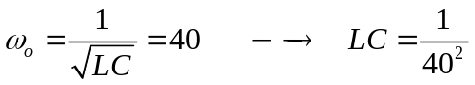
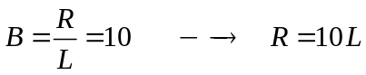
If we select R =1 Ω, then L = R/10 = 100 mH and

